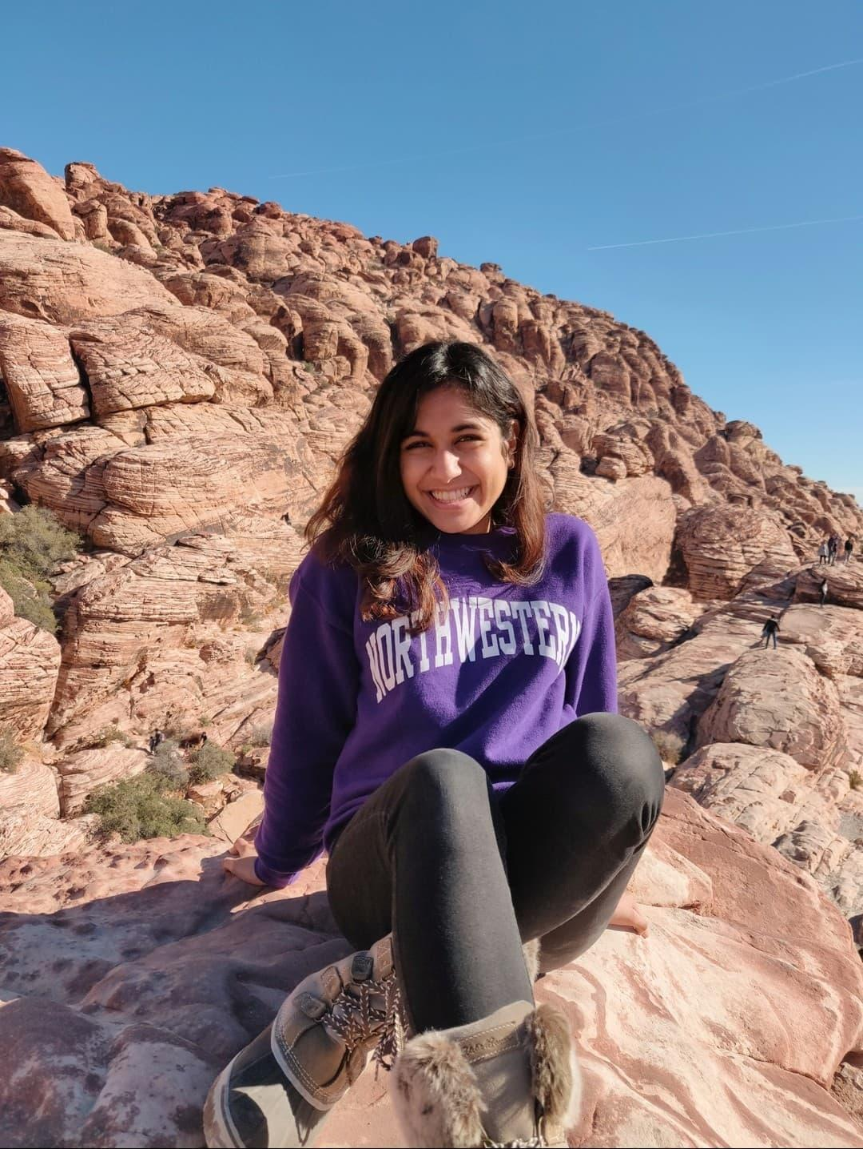
JEHANNAZ DASTOOR
Northwestern ‘20
Anthropology Major
Concentration in Biology

Jehannaz Dastoor graduated in 2020 with a major in Anthropology with a biological concentration. She will be obtaining an MD at Northwestern University Feinberg School of Medicine, and an MPH concurrently at The Graduate School at Northwestern. She hopes to continue pursuing her interest in global health, and aims to practice as a physician and contribute to community health efforts.

Q&A

How did you get involved in your research project?
I’ve been working with Angel Wings International, which is a community health organization in Haiti, every summer since I was 15. The organization is really like a second family to me, and so I've always been really passionate about global health. I also pursued an anthropology major in undergrad, so all of those passions kind of intersected in my senior year when I decided that I wanted to do a little bit more investigation into the topics that I've been learning and what I've witnessed as someone who is working in global health.

How did you decide to work on this curriculum-based project more specifically?
I started a global health organization at Northwestern to kind of form a link between the undergrad community and Haiti, and then in fall quarter of my senior year, I started an independent global health study. It originally started off as wanting to do a focused quarter solely on voluntourism, neocolonialism and learning about that dynamic, but then as we reached the end of that quarter, I thought that this is information that is really valuable. This information needs to be disseminated across the student body of undergraduates who want to do service in the global south. I pitched the idea to Dr. Peter Locke, and he suggested that I go through the department of undergraduate research to not just make it a curriculum, but to make it a research project to really be able to evaluate the efficacy of it.

What was it like seeing your work implemented?
I was really getting real time feedback after every single session. I could basically ascertain individualized feedback and understanding of every single lesson, and then be able to see all of the results pretty much directly after, which was very valuable for me to be able to think about what I want the curriculum to look like in the following years. I think it also showed me how accessible this type of research is, and how really any student goes in global health organizations that want to do this can and should, because it's such a quick turnaround in terms of understanding how effective your curriculum is. There's also then, consequently, a quicker turnaround for making changes to make that curriculum as ethical, sustainable and effective as possible.

Dismantling Voluntourism: Evaluating the Effects of a Global Health Supplemental Curriculum on Undergraduate Volunteers Travelling to Haiti
In the era of international volunteerism, mounting evidence suggests that the presence of unskilled and culturally unaware volunteers in the global south fosters “voluntourism,” and endangers the very populations and institutions that volunteers want to help. Northwestern does not enforce a pre-trip curriculum for student organizations that coordinate private service trips, leaving the students to independently prepare themselves. This spring, eight students including myself intended to volunteer in Haiti through a Haitian-based non-profit, coordinated by a Northwestern student organization. Taking this opportunity, I implemented an eight-week pre-departure global health/ethics curriculum, and assessed the students to determine if a supplemental curriculum was effective in establishing competency in global health, ethical service, and Haitian history/culture. Students were evaluated through qualitative methods and quantitative evaluations. This study found that the curriculum was sufficient in establishing cultural sensitivity, historical awareness, and basic global health/ethics competency. Students also developed a critical lens of service in the global south, and heightened awareness of how their privilege would affect their engagement in Haiti. Students preferred a supplemental curriculum to a for-credit class, and cited their schedules as barriers to taking global health classes or choosing university-sponsored international programs. Participants admitted that without the curriculum, they would not have individually sought out this information. The results of this study suggest that a country-specific supplemental curriculum is effective in creating a cohort of culturally and ethically sensitive student volunteers, and should be a minimum requirement for undergraduate service efforts in the global south.

