The Evolution of the Modern Support Group
*Angelina Anderson
Department of Biological and Physical Health Sciences, Roosevelt University Chicago, Chicago, IL, 60605
aanderson52@mail.roosevelt.edu

Abstract - This research project examines the evolution of the modern medical support group as social media continues to take a more central part in support group activity. The purpose of this project is to determine whether online support groups are pushing the bounds of support groups or if they are evolving the very definition. This analysis was conducted by looking at two Migraine support groups on Facebook that are moderated by the same administrator. Looking at posts and comments made by both the administrator as well as those by group users, I analyze how the support group is being utilized and what the motivation behind group participation may be. Through rhetorical analysis, I identify a set of post types that support group users have in common and offer hypotheses about how users enact online medical identities. Applying the insights of Ginroy and Holt, I identify a growing expectation for medical professionals to communicate with patients over the internet.^{1,3}
This project aims to determine whether support groups are changing and if so if they are changing to meet a need that is not being met by the medical community, as well as looking at how that may connect to patients' emotional and physical needs. This project may help to answer if there are any gaps in the medical community for meeting the needs of patients who have conditions like Migraines.

INTRODUCTION
This project began because I was curious about how online support groups function as a part of the larger consumer experience of medical care, especially for patients with chronic conditions, such as migraines. I became personally interested in this topic specifically because my mother and I both suffer from migraines, and she brought the initial Facebook support group to my attention, which piqued my curiosity. The Facebook support group this project looks at was founded by an administrator who suffers from migraines and also works as a patient advocate. Although members of the group are both male and female, members are largely female, ranging in age from children – whose parents are members in their stead - to senior citizens. In the beginning stages of this project, I joined and observed the Facebook group, as well as discussing the group with my neurologist, in order to determine what was interesting about the groups’ dynamics and how it may or may not be medically useful.
A support group is defined as a group of people with similar experiences or concerns, that come together to support one another and offer advice.⁹ This particular support group started by providing a space for people to discuss their migraines with other sufferers and emotionally support one another, but since the release of new treatment options in recent years, the group has grown to also include medical information collected from members and health professionals.
The goal of this project was to determine whether modern support groups are pushing the bounds of what defines a support group or if they are evolving the definition. This project aims to determine if there are gaps in the medical resources being provided for niche conditions, such as migraine, that has led to the evolution of support groups that have become a resource for medical knowledge as well as social support. The main question that this project aims to answer is: What is the motivation for users to be active on the Facebook support group, and what forms does their activity take? I want to determine what the motivation behind the support group’s changing nature may be, and if this change may be in response to a gap in the resources migraines patients should be getting from doctors and are instead being shared via the Facebook group. I hypothesized that, if the motivation for participation in the Facebook support groups is for users to fill both an emotional and informational need, then migraine patients are using the group to compensate for a gap in resources that they need.

METHODS
This project was conducted by observing and recording the posts and comments within a social support Facebook group and looking at how the group offers support to members, both social support and other resources, such as medical information. Initially, this project began looking at all of the posts and comments made in a Facebook group called “Hope For Migraine: CGRP & Emerging Treatments” run by a moderator, Shosh Rachel, created on June 25, 2018, which at the time of this writing has 9,508 followers. Since the initial proposal for the project, I have found that the name for the group has been changed multiple times, most recently on February 27, 2020, to “Hope For Migraine: Vyepti, Reyvow, Ubrelvy, Nerivio, Emgality, Ajovy, Aimovig”, and has added multiple administrators. I also noticed a second account linked to the original, called “Migraine Meanderings” started on November 18, 2018, and run solely by Shosh Rachel, with 2,938 followers at the time of this writing. Since noticing this second account after the initial project proposal and design, I decided to include it in my research and also observe and record the posts and comments from it to compare the different interactions in the two groups.
I observed and reviewed the entirety of the posts on both of the Facebook support groups, from when each was respectively started until April 13, 2020, taking a sampling of user posts from each respective group plus a sampling of any comments made on the posts sampled, as well as looking at all posts made by the moderators of the initial group. Once all the data was collected, I reviewed and analyzed the posts and developed a classification system that would allow me to analyze and compare the different types of posts and interactions. I first began by taking a sampling of posts from each Facebook group, working to get a variety of posts from users and moderators, different topics, and over the range the groups have been open.
Using the classification system, I conducted content analysis, looking at the posts to see what users either say or imply about their motivation for joining the group and to see what users are sharing and how users are sharing different information within the group. I used the classification system to observe how often each type of interaction is occurring and using that information to determine which types of interactions are the most common within the group.

- RESULTS & DISCUSSION
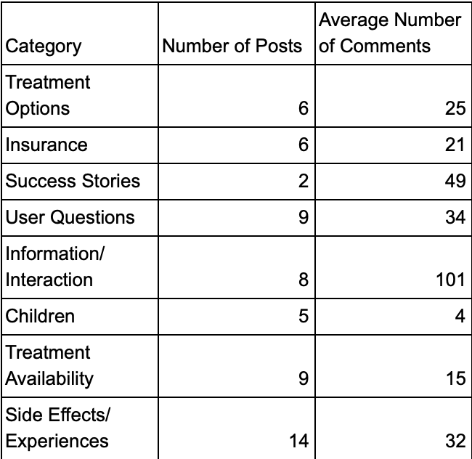

Table I. “Hope For Migraine: Vyepti, Reyvow, Ubrelvy, Nerivio, Emgality, Ajovy, Aimovig'' Activity

After collecting 40 posts from “Hope For Migraine: Vyepti, Reyvow, Ubrelvy, Nerivio, Emgality, Ajovy, Aimovig'', I categorized each of the posts and observed what the accompanying comments were discussing. Through this process, I determined the categories shown in Table I and determined the average number of comments each type of post usually obtained. Based on this sampling, posts about side effects and experiences are the most common in this group accounting for approximately 35% of the posts I sampled, although informational and interactive posts had the most average comments per post. Within this group I also noted that the majority of user comments were discussion based, as users discussed their personal experiences with migraines and different treatments. The other comment topics were usually questions, answers to questions from the post, suggestions, or encouragement.⁶
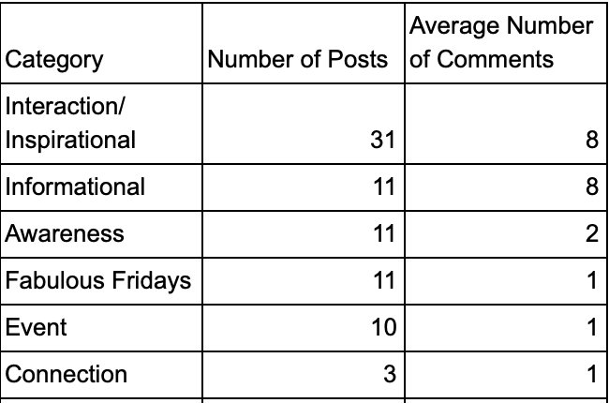

Table II. “Migraine Meanderings” Activity

As seen in Table II, I collected data on 65 posts from “Migraine Meanderings”. As shown, inspirational and interaction posts make up most of the posts in this group and have the most average comments per post, making up nearly 48% of the posts I sampled from this group. Within this group, the majority of comments were made in response to questions, offering encouragement, or discussion based on the users’ personal experiences with migraine and migraine treatments.⁷
While collecting the sampling from both “Hope For Migraine: Vyepti, Reyvow, Ubrelvy, Nerivio, Emgality, Ajovy, Aimovig'' and “Migraine Meanderings” I also noticed that it was exceedingly difficult to weed out the user posts from the moderator posts. Of the posts I sampled in “Hope For Migraine: Vyepti, Reyvow, Ubrelvy, Nerivio, Emgality, Ajovy, Aimovig'' only 55% were made by users, although nearly all of the comments were made by users. On “migraine Meanderings”, only 3% of the posts were made by users, although the majority of the comments were by users.
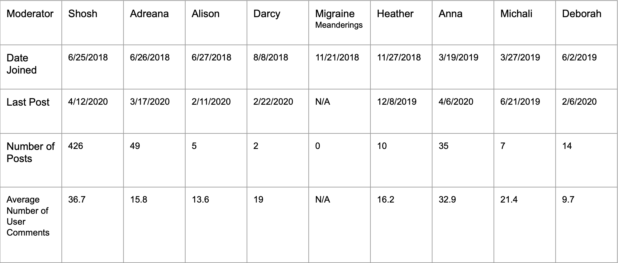
Table III. Moderator Activity in “Hope For Migraine: Vyepti, Reyvow, Ubrelvy, Nerivio, Emgality, Ajovy, Aimovig”

As evidenced in Table III, it is clear that the moderators of “Hope For Migraine: Vyepti, Reyvow, Ubrelvy, Nerivio, Emgality, Ajovy, Aimovig'' became more involved in the group over time. Table III lists the 9 moderators, the date they joined the group, the last date they made a post, the number of posts they have made, and the average number of user comments on their posts. As you can see, Shosh, who created the group, is the most involved of the moderators and has made the most posts out of the moderators, posting almost everyday of the year, and also regularly interacts with users through the comments. Based on these observations in conjunction with my observations about the small percentage of user posts, there appears to be significant evidence that this Facebook group has perhaps been moving away from a support group and instead moving towards a type of informational blog with personal components run by the moderators that allow for user comments and interaction.
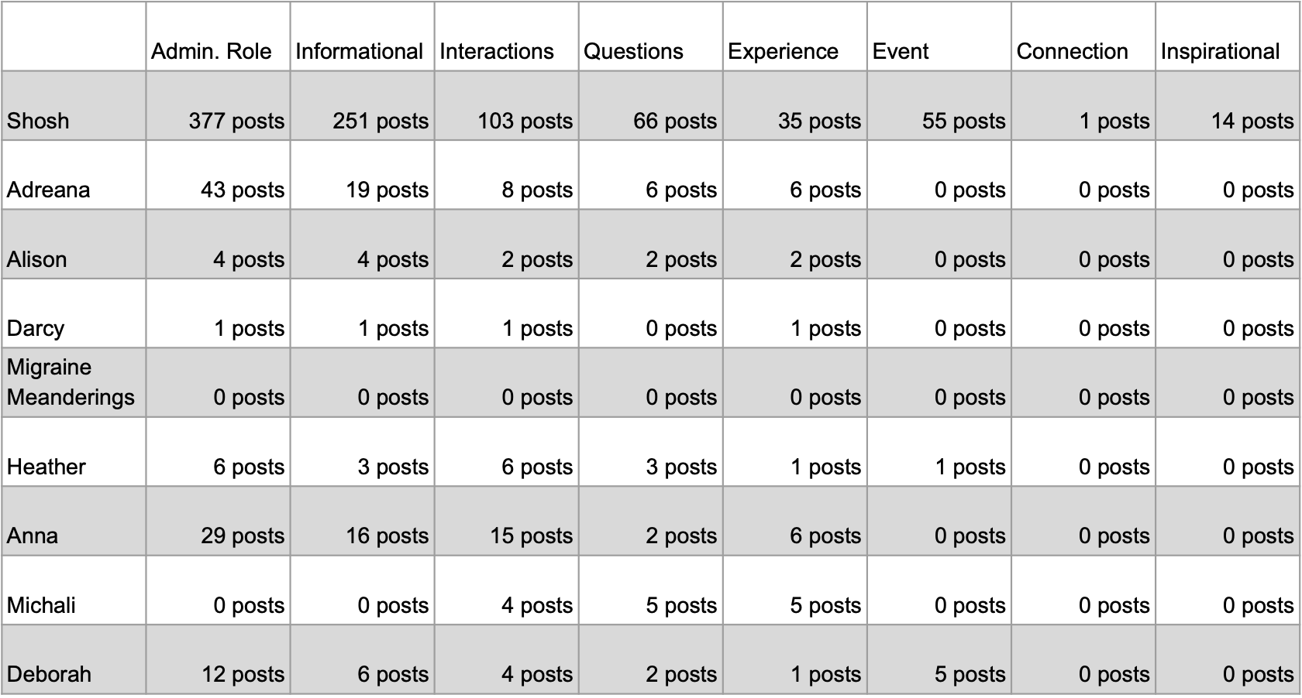
Table IV. Moderator Post Categories in “Hope For Migraine: Vyepti, Reyvow, Ubrelvy, Nerivio, Emgality, Ajovy, Aimovig”

After collecting the posts, I analyzed them, sorting each post into a category. These include posts made in an Administrative role, Informational posts, interactions, questions, experiences, events, connections, and inspirational posts. As shown in Table IV, the majority of posts were made in the moderators’ administrative role, the next largest category was then informational, and the smallest category was connections. This table also highlights the different roles each moderator took on within the group. It is clear that Shosh is the main person running the group, she makes the most posts, posting almost daily, and 88% of those posts are made in her administrative role. In contrast, Michali has zero posts made in her administrative role and 100% of her posts are experience and question based.
In the course of my research, I also found that the moderators had implemented rules for the group. Unfortunately, Facebook does not state when the rules were put in place, nor is there a post introducing them, but it is clear that they were not there from the beginning and appear to have been introduced sometime towards the end of 2018 per posts made by Shosh and Helen. These rules clearly signify the time when the moderators began to take a more active role in the interactions within the group, from what the users were posting to what users were commenting. The rules state that posts and comments that violate the rules will be deleted and that moderators hold the authority to turn off comments for posts if they find it necessary. I began observing this group before my project officially began, and have noticed that many posts since that time have disappeared most likely in accordance with these rules. It is interesting to note that any posts discussing migraine outside of the new treatments (Vyepti, Reyvow, Ubrelvy, Nerivio, Emgality, Ajovy, and Aimovig) have since been deleted, as have any posts discussing suicide, intense pain, depression, hospitalizations, and other extreme experiences relating to chronic illness, or any posts that may discuss comorbid ailments, or treatments.
Rule 1 that moderators have posted requires all users to “read the FAQs announcement before making any posts or leaving any comments”.⁶ In total there are 11 units that users are expected to read before posting or commenting on the page. Each of the units goes over a different topic, linking users to posts and files on the page that discuss the topic and answer common questions. The page also has a section that includes files of information from doctors and other resources with medical information about migraines, including the drug fact sheets for the new treatments, and all video recordings of online events the page has hosted with doctors, patient advocates, or other guests. The moderators request that users regularly respond to surveys about whether the new treatments are working for them, continuing to work, have stopped working, have side effects, and what side effects they may have, which they have then been compiling into data sheets and charts that can be accessed on the page under the files area.
Altogether, this information helps to make the Facebook page and the moderators themselves appear more credible. The immediacy, truthfulness, and consistency of information on a site can help to lend a perception of transparency, all of which are evidenced within this page and this idea can be seen in the way that users are utilizing the FAQs page as truthful and accurate information, as well as the manner in which medical professionals have agreed to participate on the page and in its events.³

CONCLUSION
Based on the user activity within “Hope For Migraine: Vyepti, Reyvow, Ubrelvy, Nerivio, Emgality, Ajovy, Aimovig'' and “Migraine Meanderings'' there is significant evidence that there are gaps within the healthcare system that the support group is working to fill by providing medical information to users. This analysis also provides significant evidence that while each users’ motivation for joining the Facebook groups varies the main reasons are to discuss their experiences with migraine with others who will understand and to gain more information about their condition and the treatments currently available. Following my initial definition of a support group, I do believe that both “Hope For Migraine: Vyepti, Reyvow, Ubrelvy, Nerivio, Emgality, Ajovy, Aimovig'' and “Migraine Meanderings'' still fall under this definition, but “Hope For Migraine: Vyepti, Reyvow, Ubrelvy, Nerivio, Emgality, Ajovy, Aimovig'' is slowly beginning to evolve this definition to also include the sharing of intimate medical information that is not a part of the typical definition of a support group.⁹
Through the moderator activity there is evidence of user activity through comments on the moderators’ posts. They are very active in responding to surveys about how their migraines are responding to treatment and interacting in different online events with guest speakers on the page by asking questions in the comments and participating in the events.
The moderator involvement also gives significant evidence that the Facebook group is indeed helping to fill a gap in the resources available to migraine patients through traditional means, as seen by the way that medical information is presented in the FAQs page, in online events hosted with medical professionals, and the information compiled about users responses to the new treatments and drug facts. These observations also make clear that in some cases the medical field has not successfully followed recommendations to consider moving onto social media for patient outreach, marketing, and other opportunities, especially when it comes to niche groups like migraine patients.² While there has long been evidence that patients are more comfortable than their physicians when it comes to interacting on the internet, it is also clear that the patient's comfort is of the utmost importance when it comes to medical care and it is becoming more apparent that the best way to ensure every patient’s comfort is by better utilizing the internet.^{4,5}
As the moderators became more involved in the groups’ goings-on, I would have expected users to either become less involved or to complain, forcing the group to return to the way it had been. Instead, users continued to be just as involved as they had been previously, if not more so. It is interesting to see how the group has changed over time, moving from being a place for migraineurs to congregate and commiserate about their suffering and instead beginning to move towards a place where migraineurs can look for information about migraine treatments and their efficacy. While overall it appears that this shift may be positive as it is providing a much needed service for migraineurs and helping to provide information about new treatments that not much is known about, it also appears to be negatively impacting users’ freedom when it comes to discussing their overall health.
This leads into some questions I am still left with: how do users feel about this change in the group dynamic? Has the change led to any users leaving the group? What if anything are the moderators doing with the user data they are compiling? What do these changes say about the spaces where connection happens? Are users giving up their freedom to post what they want in return for group information?
The results of this project are significant because they help to show how and why emotional support groups are changing over time based on participants' motivation for joining. The results also suggest there are gaps in the resources and knowledge currently available to Migraineurs within the medical system that is instead being compensated for within support groups. Many people who suffer from chronic illnesses such as Migraines tend to join support groups in order to help with their emotional needs when it comes to their overall health, but there has been growing research that shows that support groups in combination with medical treatment are being more sought after for a more comprehensive treatment plan.⁸ In light of such information, this project would also be significant in addressing these gaps within the medical community and helping to offer better care and resources, as well as making access to Migraine related information more readily available to the large community of Migraineurs. This project also helps to show the connection between a patient’s emotional needs as well as their informational and medical needs, and how the two ideas interact together in the overall well being of a persons’ health.

REFERENCES
[1] Ginory, A., Sabatier, L. M., & Eth, S. (2012). Addressing Therapeutic Boundaries in Social Networking. Psychiatry: Interpersonal & Biological Processes, 75(1), 40–48. https://doi.org/10.1521/psyc.2012.75.1.40
[2] Hino, T., Raymond. Hospitals' Current and Future Use of Social Media. Practitioner Application, 461.
[3] Holt, C. (2011). Emerging technologies: Web 2.0. Health Information Management Journal, 40(1), 33–35. https://doi.org/10.1177/183335831104000106
[4] Hoppszallern, S. (2013, January). Will patients 'like' their experience? Healthcare's Most Wired, 24–24.
[5] Lee, J. L., Choudhry, N. K., Wu, A. W., Matlin, O. S., Brennan, T. A., & Shrank, W. H. (2015). Patient Use of Email, Facebook, and Physician Websites to Communicate with Physicians: A National Online Survey of Retail Pharmacy Users. Journal of General Internal Medicine, 31(1), 45–51. doi: 10.1007/s11606-015-3374-7
[6] Rachel, S., Dawn, H., Webster, A., Valicenti Fiem, A., Lyn, D., Williams, A., & Lerner, M. (2018, June 25). Hope For Migraine: Vyepti Reyvow Ubrelvy Nerivio Emgality Ajovy Aimovig. Retrieved from https://www.facebook.com/groups/CGRPandMigraine/
[7] Rachel, S. (n.d.). Migraine Meanderings. Retrieved from https://www.facebook.com/migrainemeanderings/
[8] Steinke, B. (2000). Rehabilitation Initiatives by Disability Self-help Groups: A Comparative Study. International Social Security Review, 53(1), 83–107. doi: 10.1111/1468-246x.00064
[9] Support Group. (n.d.). Retrieved from https://www.merriam-webster.com/dictionary/support group

