MELK Inhibition in MLL-rearranged ALL
Margaret Colton, Bartholomew Eisfelder, and *Wendy Stock
a: Department of Hematology/Oncology, University of Chicago, Chicago, IL, 60637
mcolton@uchicago.edu
wstock@medicine.bsd.uchicago.edu

Abstract - MLL-rearranged Acute Lymphoblastic Leukemia is a subset of leukemia characterized by a translocation of the MLL gene and an aberrant gene expression profile. Patients with this type of ALL face a poorer prognosis and limited treatment options. One possible target for treatment is FLT3, a receptor tyrosine kinase frequently upregulated in MLL-r ALL. Attempts to treat MLL-r ALL by inhibiting FLT3 expression have demonstrated some efficacy but fail to achieve results at clinically relevant doses. This study investigates the efficacy of OTS167, an inhibitor of MELK, which has been shown to downregulate the expression of FLT3 in other types of leukemia. In MLL-r ALL, OTS167 diminished cell viability at clinically relevant doses, and downregulated FLT3 in a post-transcriptional manner. Knockdown of MELK by siRNA also downregulated FLT3 expression, however knockdown of FLT3 failed to show any effect on cell viability. These findings indicate that OTS167 may have clinical efficacy in MLL-rearranged ALL but that the mechanism of action may not by FLT3-mediated.

Introduction
MLL-rearranged leukemia is a subset of leukemia characterized by a chromosomal translocation of the MLL gene, an epigenetic regulator. The official name for this gene in now KMT2A, but because the disease is still known as MLL-rearranged leukemia, the name MLL will be used for clarity. The MLL gene is located on chromosome 11q23, and can be translocated to many different locations in the genome. Over 50 different translocations have been reported.¹ Following translocation, MLL fuses to a fusion partner protein and begins to aberrantly regulate gene expression, giving rise to the leukemic phenotype.¹ Leukemias with this feature have a poorer prognosis, with more treatment resistant disease, and are the most common abnormality in infants with acute leukemia.²
One of the most frequently overexpressed proteins in MLL-rearranged Acute Lymphoblastic Leukemia is FLT3.³ FLT3 is a receptor tyrosine kinase that normally drives cell proliferation and survival during hematopoietic and immune cell development.⁴ MLL-rearranged ALL overexpresses FLT3 and has been shown to be sensitive to inhibition of FLT3 kinase activity.⁵ However, clinical trials using FLT3 inhibitors in MLL-rearranged ALL failed to show clinical benefits at tolerable doses.⁶ This may be due to the fact that FLT3 is heavily overexpressed in this leukemia, so a drug that inhibits the kinase activity may not be able to fully inhibit the activity unless it is administered at high doses. One way to circumvent this challenge is to target FLT3 not by inhibiting its activity, but by inhibiting its expression.
OTS167 is a novel kinase inhibitor of Maternal Embryonic Leucine-zipper Kinase (MELK), a regulator of cell cycle progression that is highly expressed in many different types of cancer, including leukemia.⁷ While studying this drug in FLT3-mutated AML, our lab discovered that administration of OTS167 led to diminished FLT3 expression in these cells. Due to this effect, we hypothesized OTS167 may downregulate aberrant FLT3 expression in and inhibit growth and cell survival in MLL-r ALL. Therefore, this study aimed to characterize the effect of OTS167 on the viability of MLL-rearranged ALL cells and on the expression of FLT3 in those cells.

Method
Cell Culture: Cell lines used in this study (KOCL-69, KOPB-26, KOPN-8 and JURKAT) were maintained at 37 °C and 5% CO₂ in media consisting of RPMI, 5% penicillin/streptomycin, 50% Fetal Bovine Serum and 5% L-Glutamine.

Cell Viability Assay: Cell viability assays for this project were performed by treating cells in triplicate with serially diluted doses of OTS167. The cells were incubated at 37 °C for 72 hours. Cells were then treated with CCK-8 solution at a 1:20 dilution and incubated at 37 °C for 4 more hours. The plates were then read in a Biotek Synergy H4 microplate reader at wavelengths of 490 and 630 nm, and the difference calculated.

Cycloheximide Washout: Cells plated at 0.5E6 cells/mL were treated with 100 mg/mL cycloheximide for 4 hours. Following the 4 hours, cells were washed twice with fresh media, spun at 100 g for 10 minutes each wash. The cells were then treated with either plain media or media containing 100nM OTS167 for 18 hours.

Western Blot: Cells were collected from cell culture and washed twice with PBS. The cells were lysed using and lysate collected through centrifugation. Lysates were separated on SDS-PAGE gel and transferred to a membrane. Membranes were blocked in 5% milk or BSA for one hour and then incubated overnight at 4°C with primary antibody. Afterwards, membranes were washed with 1x-TBS-T and incubated with HRP-conjugated secondary antibodies for 2 hours. Following a second TBS-T washing, membranes were developed using ECL Western Blotting Detection reagents.

RNA Expression Quantification: RNA lysates were collected from cells by lysing with 500 uL RNA STAT-60. cDNA was synthesized from the mRNA using the TaqMan Advanced miRNA cDNA Synthesis Kit. qPCR was performed with this cDNA using TaqMan Advanced Master Mix and probes.

siRNA Knockdown: Transfection of the cells was achieved by adding 10uM MELK or 2uM siRNA to 3.5e6 cells and electroporating at 180V for 12mS. Following electroporation cells were incubated in normal culture conditions and analyzed via Western Blot or CCK-8.

Results & Discussion
MLL-rearranged ALL cell lines show upregulated expression of MELK and FLT3
To begin investigating the contributions of MELK and FLT3 to the viability of MLL-r ALL cells, it was first necessary to determine the amount of MELK and FLT3 expressed by the cells under normal growth conditions. To this end, protein lysates were collected from the three MLL-r ALL cell cultures used in this study and protein expression was investigated via Western blot. Two additional protein lysates were run as a point of comparison. A lysate from JURKAT cells, a T-cell ALL cell line lacking an MLL rearrangement, and a lysate from normal CD34+ human leukocytes were also run on the Western blot. Compared to primary CD34+ cells, the ALL cell lines showed elevated expression of MELK. The 3 MLL-r ALL cell lines also showed high expression of FLT3. (Figure 1) CD34+ cells typically express FLT3 protein, but it was undetectable in this exposure. This aberrant expression suggested that FLT3 may be contributing to cell survival and inhibition by OTS167 might have an observable effect on cell viability.
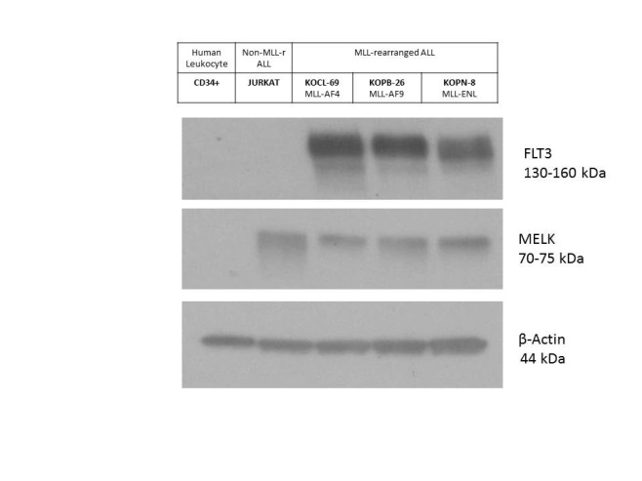
Fig.1. FLT3 and MELK expression in normal CD34+ human leukocytes, a human ALL cell line lacking an MLL rearrangement (JURKAT), and three human MLL-rearranged ALL cell lines harboring 3 different fusion protein partners (AF4, AF9, ENL). Cell lysates were collected under normal culture conditions.
MLL-r ALL cell lines are sensitive to inhibition by OTS167
To determine the sensitivity of MLL-r ALL cell line survival to OTS167, a cell viability assay was performed. Cells were treated with serially-diluted doses of OTS167 ranging from 500 nM to 1.95 nM and then incubated at 37 ℃ for 72 hours. After 68 hours, the cells were treated with CCK8, a reagent that reports cell viability by changing color in response to dehydrogenase reactions, for 4 hours.
The cell lines responded to OTS167 with a decrease in cell viability. All of the MLL-r ALL cell lines responded similarly to the drug, exhibiting similar dose-response curves and IC₅₀ values between 10 and 20 nM. (Figure 2A-C) Notably, the JURKAT cell line behaved differently. Although the cells were also responsive to the drug, eventually reaching near-zero percent cell viability in the higher doses, the JURKAT cells were less sensitive to the drug. The IC₅₀ for these cells was roughly double that of the cell lines with MLL-rearrangements. (Figure 2D)
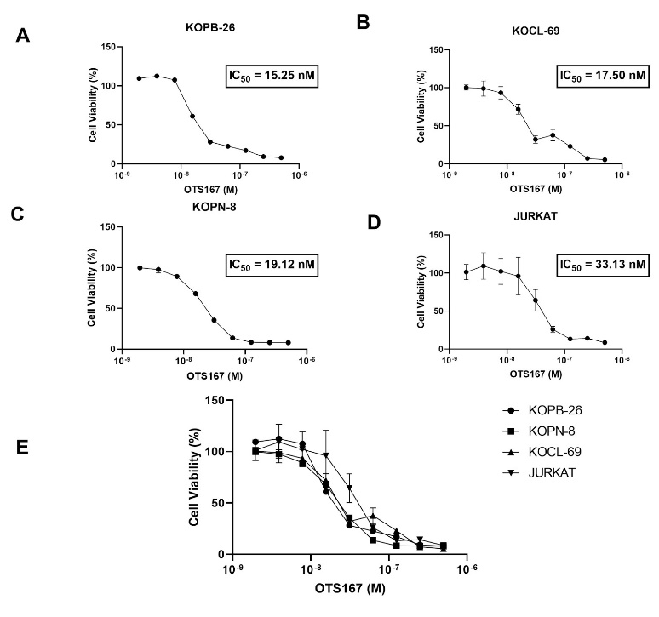

Fig. 2. Cell viability analysis of ALL cell lines. Cells treated with serially-diluted doses of OTS167 for 72 hours were tested for viability via CCK-8 assay. Dose response curves were created from the cell viability values and IC₅₀ values calculated from these curves. A-D) Individual dose-response curves for KOPB-26 (A), KOCL-69 (B), KOPN-8 (C) and JURKAT (D) cell lines. E) Super-imposition of all dose-response curves.
OTS167 downregulates FLT3 expression in a post-transcriptional manner
Previous studies from our lab reported that in FLT3-mutated AML cell lines, OTS167 downregulated the expression of FLT3. To determine whether FLT3 expressed by MLL-r ALL cell lines could be downregulated, FLT3 expression was measured by Western Blot after treatment with OTS167. Treatment of KOCL-69 cells with 50 nM OTS167 led to decreased expression of FLT3 after 24 and 48 hours. (Figure 3A) Having demonstrated an effect on FLT3 expression, it was then necessary to determine at which point in the expression of FLT3 OTS167 intervened. To elucidate this, a cycloheximide wash-out experiment was performed.
Cycloheximide is a drug that reversibly halts translation. The drug can be used to observe nascent protein translation following washout because transcription still occurs normally when the drug is present. Once the cycloheximide is washed out, translation can resume as normal. For this experiment, cycloheximide was applied to the cells for 4 hours and then washed out. Following wash-out, cells were either incubated in fresh media for 18 hours or incubated in fresh media with 50 nM OTS167 for 18 hours.
In the KOCL-69 and KOPB-26 cell lines, the cycloheximide predictably depleted the pool of FLT3 protein. Following wash-out, both the media-incubated and OTS167-incubated cell lines began translating FLT3 again, although the OTS167-incubated cells failed to replenish FLT3 to the same extent that the media-incubated cells achieved. Particularly, the 130 kDa band, which represents newly translated FLT3 that has not yet been glycosylated, was fully lost after cycloheximide treatment and was only fully replenished by the media-treated cells. (Figure 3B) To determine whether the loss of nascent FLT3 was due to decreased FLT3 mRNA, parallel treated samples were assayed for FLT3 mRNA by qPCR. The amount of FLT3 mRNA present in the cell did not change between the media-incubation and OTS167-incubation conditions. (Figure 3C)
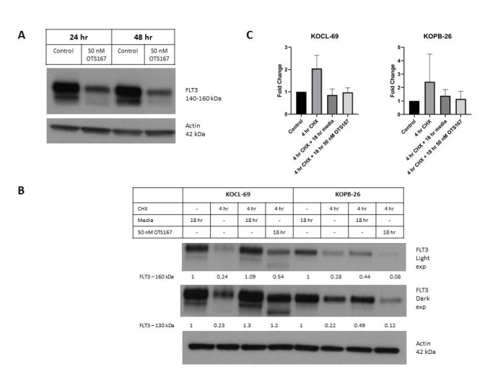
Fig. 3. FLT3 expression following OTS167 treatment and cycloheximide wash-out. A) FLT3 expression in KOCL-69 cells following 24 hours and 48 hours of treatment with 50 nM OTS167. B) FLT3 expression in KOCL-69 and KOPB-26 cells. Where indicated, cells were treated with 100 mg/mL cycloheximide (CHX) for 4 hours, after which the CHX was washed out. Numbers below the bands indicate band quantification values obtained by calculating the ratio of black and white pixels in the image. C) qPCR results of FLT3 mRNA normalized to GAPDH mRNA. Fold change values were taken from three replications and averaged to determine change in FLT3 mRNA across all conditions.
Knockdown of MELK validates protein expression findings while knockdown of FLT3 fails to produce effects on cell viability
To confirm that the effect of OTS167 on the expression of FLT3 was driven by the inhibition of MELK, an siRNA-mediated MELK knockdown was performed on KOCL-69 cells. These cells were selected because they demonstrated the strongest inhibition of FLT3 expression following OTS167 treatment. (Figure 3C) Knockdown of MELK was achieved, and 24 hours after knockdown, FLT3 expression was reduced by 15%. MELK began to be expressed again at 48 hours after knockdown, and by 72 hours after knockdown, FLT3 expression was restored. (Figure 4A)
To test whether the overexpression of FLT3 drives cell survival, it was necessary to test the effect of FLT3 on cell viability by performing an siRNA-mediated knockdown of FLT3 and measure the effect on cell viability by CCK8 assay. In all 3 MLL-rearranged ALL cell lines, FLT3 knockdown was achieved and maintained through 48 hours after electroporation. (Figure 4B) No significant effect on cell viability was observed after 48 hours (Figure 4C) or 72 hours (not shown).
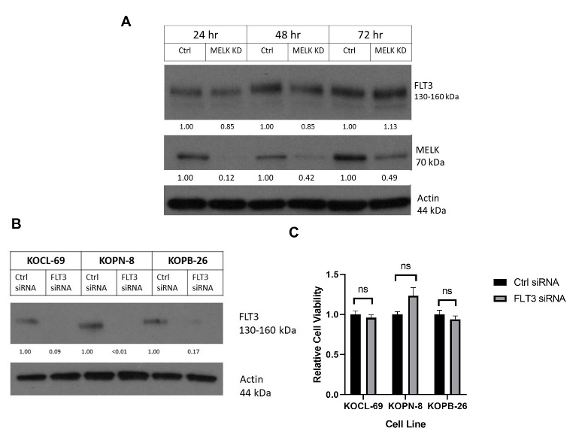
Fig. 4. Protein expression and cell viability following siRNA-mediated knockdown. A) FLT3 and MELK expression in KOCL-69 cells following 24, 48 and 72 hr MELK siRNA-mediated knockdown. Numbers below the bands indicate band quantification values. B) FLT3 expression in MLL-r ALL cell lines following 48 hr FLT3 siRNA-mediated knockdown. Numbers below the bands indicate band quantification values. C) Cell viability of MLL-r ALL cell lines following 48 hr FLT3 siRNA-mediated knockdown.

Conclusion
Western blot analysis of MLL-rearranged ALL cell lines showed that the cells express high levels of MELK and FLT3. Inhibiting this MELK via OTS167 led to a decrease in cell-viability at relatively low doses. A downregulation of FLT3 was observed with OTS167 treatment, and cycloheximide washout experiments as well as qPCR indicated that this effect was post-translational.
siRNA-mediated knockdown of MELK led to decreased expression of FLT3, confirming that the observed post-translational effect of OTS167 was, in part, due to the inhibition of MELK. However, knockdown of FLT3 showed no effect on the viability of the cells. This calls into question the hypothesis that FLT3 is essential for the growth of MLL-rearranged ALL and that the overexpression of FLT3 is a driver for the cancer.
One possible explanation is that the knockdown of FLT3 was incomplete. While knockdown was achieved for all 3 cell lines, expression of FLT3 was not fully ablated. It is possible that even the small amount of FLT3 expressed by the cells was able to sufficiently signal and continue driving cell proliferation. In that case, a full knockout of FLT3 would reveal an effect on cell viability.
However, previous studies that have fully ablated FLT3 expression in MLL-rearranged ALL cells similarly found that the lack of FLT3 expression did not affect the viability of the cells or the development of cancer in vivo.¹⁰ Thus, it is possible that FLT3 is not always essential to MLL-rearranged ALL or that the observed effect of OTS167 is due to another MELK-driven pathway. Analyzing the FLT3-knockdown cells on a single-cell level, through flow cytometry for example, would reveal whether any subset of cells was dependent on FLT3 for survival.
MELK may affect FLT3 expression by promoting its translation. MELK is a known activator of eIF4B, a component of the eIF4F protein complex, also called the Pre-Initiation Complex (PIC).¹¹ The eIF4F protein complex regulates the translation of certain mRNAs by unwinding the mRNA and allowing for easier access by ribosome. The complex is particularly crucial for long and highly-structured mRNAs with long 5’-UTRs that form G-quadruplexes made of guanine-rich motifs.¹² If FLT3 is an eIF4F-dependent mRNA, then the observed downregulation of FLT3 expression following inhibition of MELK by OTS167 may be due to the requirement for MELK-eIF4B interaction. This could be tested by knocking down eIF4B expression in these cells and measuring FLT3 expression. If FLT3 is dependent on eIF4B for translation, then expression of FLT3 should decrease
OTS167 demonstrates inhibition of cell viability and FLT3 expression in cell lines, indicating some potential for clinical efficacy. However, the relevance of these findings will be stronger if they can be recreated in other models. These effects on viability must be recreated in more clinically relevant models such as primary patient samples and mouse models of MLL-rearranged ALL. If these models also demonstrated inhibition of cancer growth at relatively low doses of OTS167, then this would indicate

References
[1] Yokoyama, A. (2015). Molecular mechanisms of MLL-associated leukemia. International Journal of Hematology, 101(4), 352–361. https://doi.org/10.1007/s12185-015-1774-4
[2] Winters, A. C., & Bernt, K. M. (2017). MLL-Rearranged Leukemias—An Update on Science and Clinical Approaches. Frontiers in Pediatrics, 5. https://doi.org/10.3389/fped.2017.00004
[3] Armstrong, S. A. et al. (2002). MLL translocations specify a distinct gene expression profile that distinguishes a unique leukemia. Nature Genetics, 30(1), 41–47. https://doi.org/10.1038/ng765
[4] Rosnet, O. et al. (1996). Human FLT3/FLK2 receptor tyrosine kinase is expressed at the surface of normal and malignant hematopoietic cells. Leukemia, 10(2), 238–248.
[5] Brown, P. et al. (2005). FLT3 inhibition selectively kills childhood acute lymphoblastic leukemia cells with high levels of FLT3 expression. Blood, 105(2), 812–820. https://doi.org/10.1182/blood-2004-06-2498
[6] Stam, R. W. . et al.. (2005). Targeting FLT3 in primary MLL-gene-rearranged infant acute lymphoblastic leukemia. Blood, 106(7), 2484–2490. https://doi.org/10.1182/blood-2004-09-3667
[7] Chung, S. et al. (2012). Development of an orally-administrative MELK-targeting inhibitor that suppresses the growth of various types of human cancer. Oncotarget, 3(12), 1629–1640.
[8] Benito, J. M. et al. (2015). MLL-Rearranged Acute Lymphoblastic Leukemias Activate BCL-2 through H3K79 Methylation and Are Sensitive to the BCL-2-Specific Antagonist ABT-199. Cell Reports, 13(12), 2715–2727. https://doi.org/10.1016/j.celrep.2015.12.003
[9] Khaw, S. L. et al. (2016). Venetoclax responses of pediatric ALL xenografts reveal sensitivity of MLL-rearranged leukemia. Blood, 128(10), 1382–1395. https://doi.org/10.1182/blood-2016-03-707414.
[10] Albouhair, S. et al. (2013) “Flt3 Does Not Play a Critical Role in Murine Myeloid Leukemias Induced by MLL Fusion Genes,” PLoS ONE, 8(8), doi: 10.1371/journal.pone.0072261.
[11] Wang, Y. et al. (2016). Mitotic MELK-eIF4B signaling controls protein synthesis and tumor cell survival. Proceedings of the National Academy of Sciences of the United States of America, 113(35), 9810–9815. https://doi.org/10.1073/pnas.1606862113
[12] Malka-Mahieu, H. et al. (2017). Molecular Pathways: The eIF4F Translation Initiation Complex—New Opportunities for Cancer Treatment. Clinical Cancer Research, 23(1), 21–25. https://doi.org/10.1158/1078-0432.CCR-14-2362

