Radiator Energy Modelling with Wireless Open-Source Sensors
Urwa Irfan,ª Akram Syed Ali, ª Christopher Riley, ª and *Brent Stephens ª
a: Department of Civil, Architectural, and Environmental Engineering, Illinois Institute of Technology, Chicago, IL 60616
uirfan@hawk.iit.edu
brent@iit.edu

Abstract- The purpose of the research is to develop an efficient, economical method of determining the energy consumption of the steam radiators in Alumni Memorial Hall. Custom printed circuit boards (PCBs) were designed and assembled to act as sensors for measuring the air temperature of rooms and the surface temperature of radiators. These sensors were installed in faculty offices in Alumni Hall, with the air temperature sensors mounted on the wall and the surface temperature sensors on the steam inlet and condensate outlet pipes of each radiator. These sensors are designed to transmit data wirelessly to a host computer. Using data from the sensors as well as the dimensions of the radiator unit, the heat flux output from the radiator can be estimated. These results when compared with measurements from actual heat flux sensors mounted on the radiator show that the modelled data is reasonably accurate (correlation with R² > 0.9). With some fine-tuning, the model can replace expensive heat flux sensors in evaluating radiator energy usage. This type of setup can be used to provide estimations of thermal comfort, along with better control of radiator operation in order to save energy utilization and costs.

- Introduction
This project aims to develop a reliable method of evaluating the energy consumption of the steam radiators in Alumni Memorial Hall. The capacity to efficiently track energy usage can in turn facilitate improved regulation of the radiators, economizing on energy expenses. Thus, it pertains to the IIT Engineering theme of Energy. Once established, it can easily be expanded to other types of heat exchanger devices.
Open-source temperature sensors developed by the Built Environment Research Group (BERG) at IIT were first calibrated with equivalent commercial devices.^{1,2} Using these sensors, the temperatures on the surface as well as at the condensate pipe of a radiator in an Alumni Hall office were measured, and subsequently used to determine its heat flux output. A commercial heat flux sensor was also installed on the radiator; the comparison between the two methods is demonstrated in this paper.

- method
The custom-built sensors used are based on Arduino hardware and software. These wirelessly transmit data to a control node by means of a USB gateway, which eliminates the need to install a separate data logger. Their readings can also easily be monitored to ensure proper operation without disturbing the setup on the radiators.
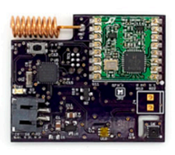
Fig. 1. PCB for temperature sensor. ¹
Calibration was carried out with two open-source sensors besides two standard commercial devices deployed on a radiator in an office in Alumni Memorial Hall. These were attached a few centimeters apart, the HOBO sensors vertically below, onto a single radiator fin. The radiator switches on when the room is occupied. The standard instruments used, TMC20-HD sensors connected to Onset HOBO U12-012 data loggers, have been extensively employed by the scientific community.^{3,4} Their accuracy is quoted as ± 0.35°C. Data was collected over a span of two weeks at 1-minute intervals.
The heat flux output for an Alumni Hall radiator was modelled using data from two open-source temperature sensors measuring the temperatures at the radiator surface and the condensate pipe. The data collection occurred over a period of six days, also at 1-minute intervals. Fluxteq heat flux sensors were used as the commercial counterparts. These are also well-established, widely used sensors. ^{5,6}
The heat flux (rate of heat transfer per unit surface area) can be obtained using the following heat transfer relation and associated equations:
Q̇ = √( ΔT) (1)
m = √ (2)
L_{c} = L + t/2 (3)

A_{fin} = 2wL_{c} (4)
where ΔT is the change in temperature between the inlet and outlet, i.e. the radiator surface and the condensate.⁷
The dimensions of a single radiator fin were measured and are noted in Table 1 alongside the material constants used. The total number of fins on the radiator is 42. The thermal conductivity of the cast iron radiator and the convective heat transfer coefficient are assumed to remain constant over the surface of the radiator. Any heat generation in the fin itself is not considered.

TABLE 1. Radiator dimensions and heat transfer constants
thermal conductivity (k) | 45.5 W m⁻¹ K⁻¹ (taken for plain grade 20 cast iron)⁸
convective heat transfer coefficient (h) | 17.38 W m⁻² K⁻¹ (for forced convection of air)⁹
width (w) | 3.25 inches
length (L) | 23 inches
thickness (t) | 1 inch

- results & DISCUSSION
The temperature measurements collected using the custom sensors and HOBO sensors are represented in Figure 2. The temperatures follow the same overall trend, with the custom devices having slightly higher peak values at instances of the radiator heating up.
Unsurprisingly, the equivalent devices show strong linear correlations (both with R² > 0.99) as seen in Figures 3 and 4. Figures 5 and 6 show the inter-sensor correlations.
Figure 7 illustrates the heat flux output, both modelled and actual, plotted against time. The linear correlation between the modelled and standard data is shown in Figure 8.
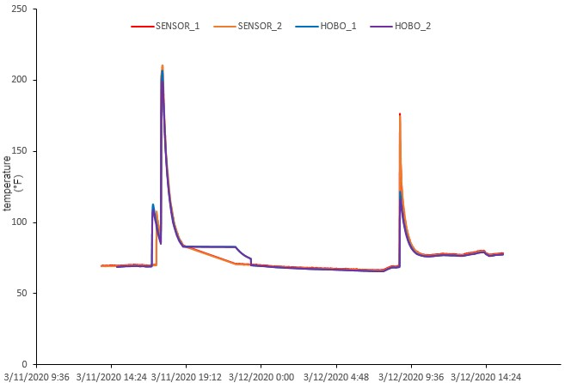
Fig. 2. Temperature time-series data
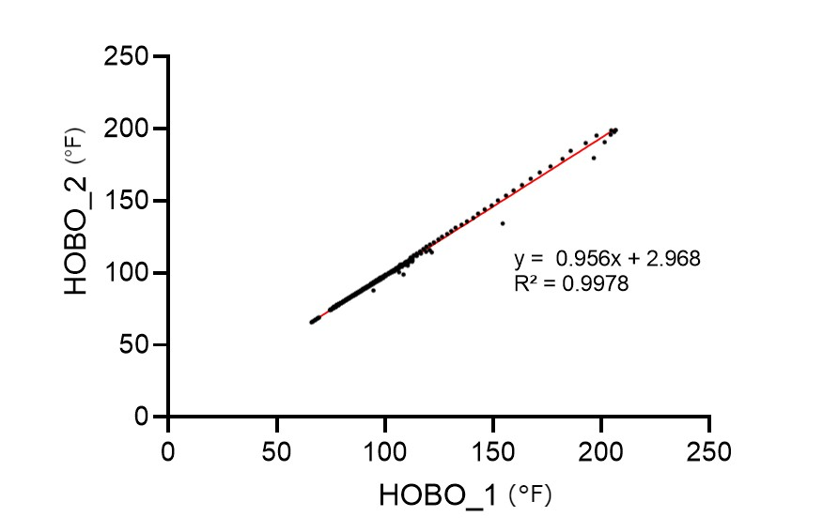
Fig. 3. Correlation between the two HOBO sensors

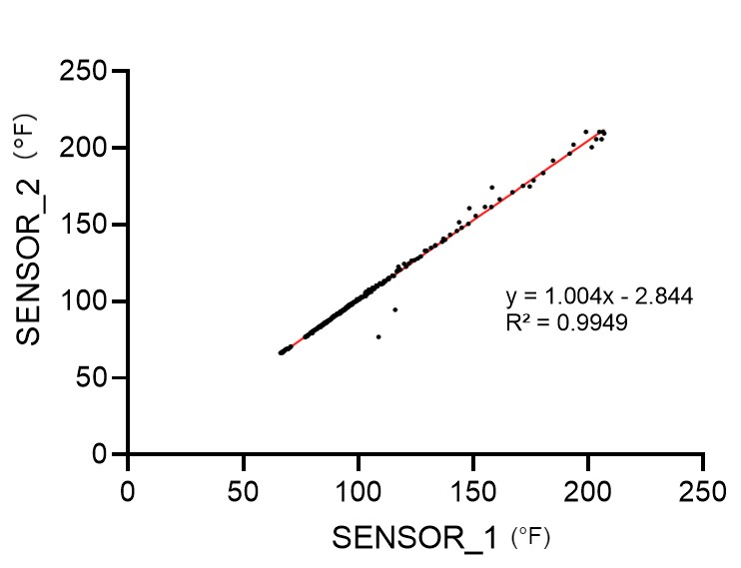
Fig. 4. Correlation between the two open-source sensors

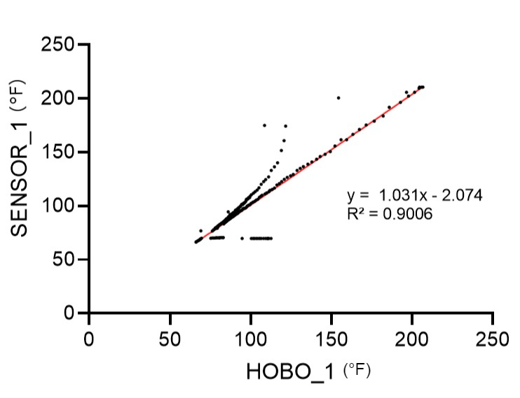
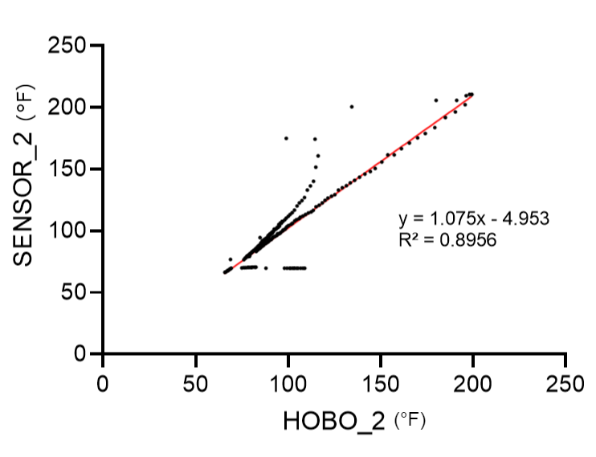
Fig. 5-6. Correlations between the custom and HOBO sensors

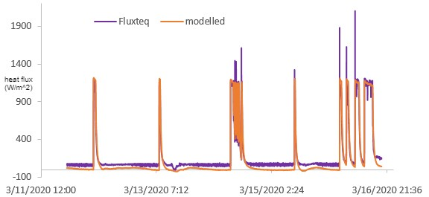
Fig. 7. Heat flux time-series data: measured and modelled
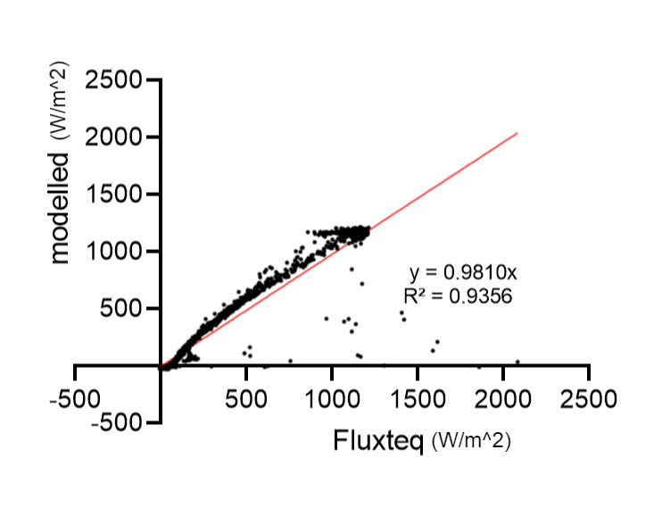
Fig. 8. Correlation between actual and modelled heat flux data

The results indicate that the custom-built sensors are fairly accurate, as the commercial data loggers corroborate their temperature readings. The error in the temperature peaks can be accounted for by the heat transfer in the radiator: the two types of sensors could not have been placed in exactly the same spot, hence the temperatures measured were not wholly in sync. The room was not occupied for long on each occasion, which resulted in the radiator being switched off before the entirety of the fin could reach a uniform temperature. The following stills from a video taken of a particular radiator during the process of heating illustrate this situation.

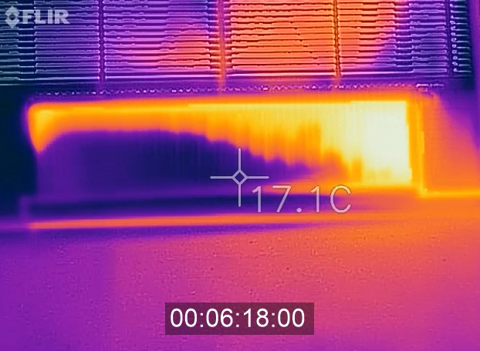
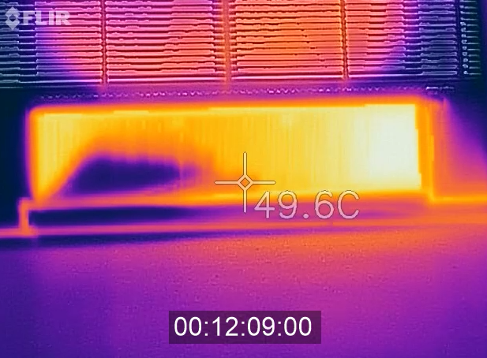
Fig. 8-9. Images showing heat transfer in a radiator in Alumni Memorial Hall.

The strong correlation seen between the modelled and actual heat flux data supports the conclusion that the open-source sensors and model are well-grounded.

- Conclusion
The goal of this research was to evaluate an inexpensive alternative for determining radiator energy consumption. It can be concluded that the demonstrated heat flux model is a suitable procedure for computing the energy output of the steam radiators in Alumni Hall, and can be replicated in heat exchangers elsewhere. Further investigation could involve expanding the project to the entire building.

- Acknowledgements
I would like to express my appreciation to the Armour College of Engineering (ACE) Undergraduate Research Program for their funding of this research. I also wish to thank Akram Ali, for his effort and guidance during the course of the project, and my parents, for their continued encouragement and support.

- referEncES
[1] Ali, A. S., Coté, C., Heidarinejad, M., & Stephens, B. (2019). Elemental: An open-source wireless hardware and software platform for building energy and indoor environmental monitoring and control. Sensors. 19(18). https://doi.org/10.3390/s19184017
[2] Ali, A. S., Zanzinger Z., Debose D., & Stephens B. (2016). Open Source Building Science Sensors (OSBSS): A low-cost Arduino-based platform for long-term indoor environmental data collection. Building and Environment. 100, 114-126. https://doi.org/10.1016/j.buildenv.2016.02.010
[3] Haaland D., Tzekova E., Purcell B., &. Siegel J. (2016). Pre-retrofit assessment of thermal comfort and excess moisture in post-war multi-unit residential buildings in Toronto. ASHRAE.
[4] Ngarambe, J., Yun G. Y., & Kim G. (2019). Prediction of indoor clothing insulation levels: A deep learning approach. Energy and Buildings. 202(109402). https://doi.org/10.1016/j.enbuild.2019.109402
[5] Babak, V., Dekusha O., Kovtun S., & Ivanov S. (2019). Information-Measuring System for Monitoring Thermal Resistance. Archived Volume. 102.
[6]Jung, W., Chan M., Jazizadeh F., & Diller T. E. (2019). Feasibility assessment of heat flux sensors for human-in-the-loop HVAC operations. Proceedings of the ASCE International Conference on Computing in Civil Engineering. 251-258.
[7] Çengel, Y. A., J. M. Cimbala, R. H. Turner. (2017). Fundamentals of Thermal-Fluid Sciences. (5th ed., pp. 680-690). McGraw-Hill Education.
[8] Holmgren, D.. (2005). Review of thermal conductivity of cast iron. International Journal of Cast Metals Research. 18. 331-345. https://doi.org/10.1179/136404605225023153
[9] Wernik, J., Grabowski, M., & Wołosz, K. J. (2018). Thermal analysis of radiator under natural and forced convection conditions using numerical simulation and thermography. Chemical Engineering Transactions, 70, 1501-1506. https://doi.org/10.3303/CET1870251

